 Majestic Gold Corp. T S X V : M J S · F S E : M J T

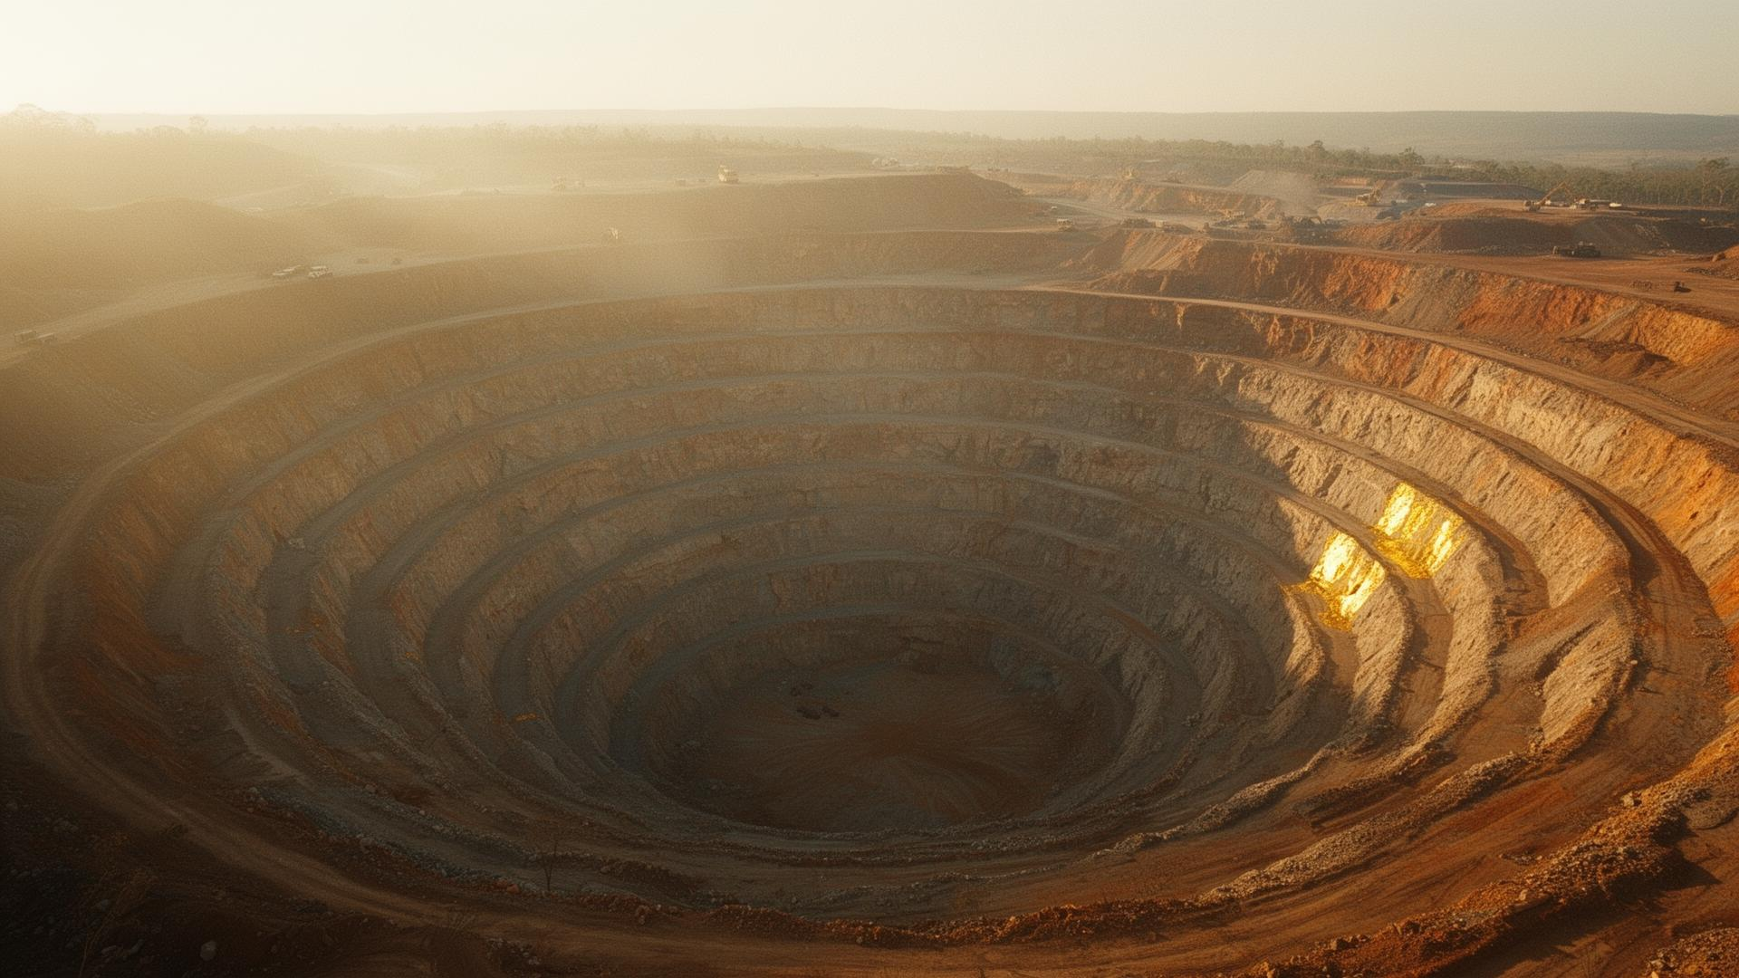
A N N U A L R E P O R T · 2 0 2 5
A company,
in its own hand.

Producing gold operations across China, Africa, Australia and Canada.

L E T T E R F R O M T H E C E O

A year measured in patience.

2025 asked us to do the unglamorous things well: tighter haul cycles, a clean mill reline, and the patient underground development that pays back in 2026.
Dear shareholders,
This is the year we chose discipline over headlines. Our team in Shandong delivered Q4 production of 28,400 ounces — ahead of internal guidance — while completing the planned mill reline and resuming underground development on schedule.
Across the portfolio, the work was quieter than the reports usually suggest. In Western Australia, the satellite underground project moved into feasibility. In Yukon, the permitted starter pit at Tagish Lake stayed on its schedule. In southern Africa, the Sefako operation closed the year with a measured grade improvement.
We took on no new debt, paid down none we did not have, and added US$8.5 million to cash. This is a company being run for the long horizon — the one that earns the right to be read in twenty years, not just twenty quarters.
Stephen Kenwood, P.Geo.
P R E S I D E N T & C E O

